**Fatima Jinnah Women University**

Department of Software Engineering

**LAB 11**

**Name:** Raifa Khalid

**Reg. no:** 2020-BSE-024

**Section:** A

**Semester:** Fourth

**Course:** Data Base (LAB)

**EXAMPLES:**

*Insert Rows:*

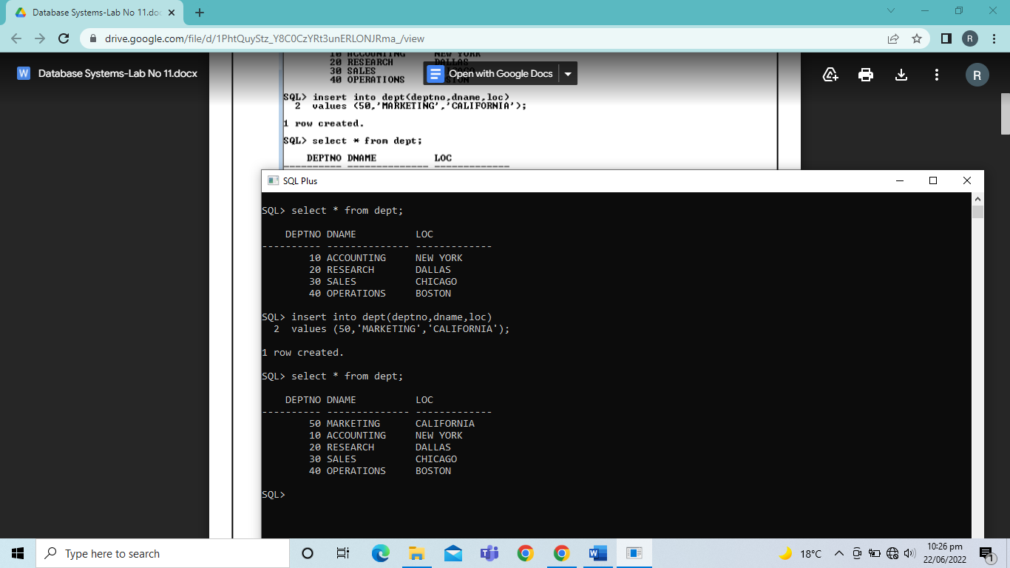

*Insert Rows with Null Values:*

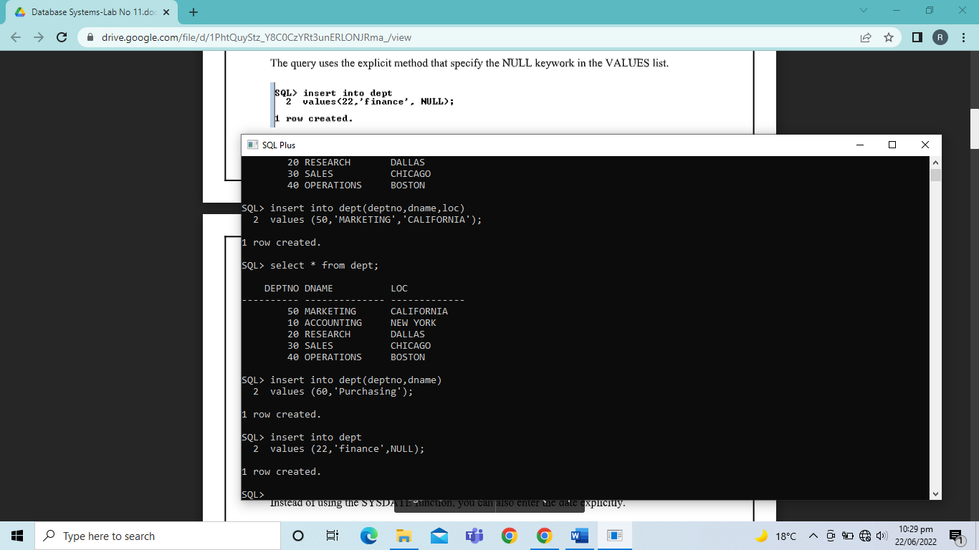

*Inserting Special Values:*

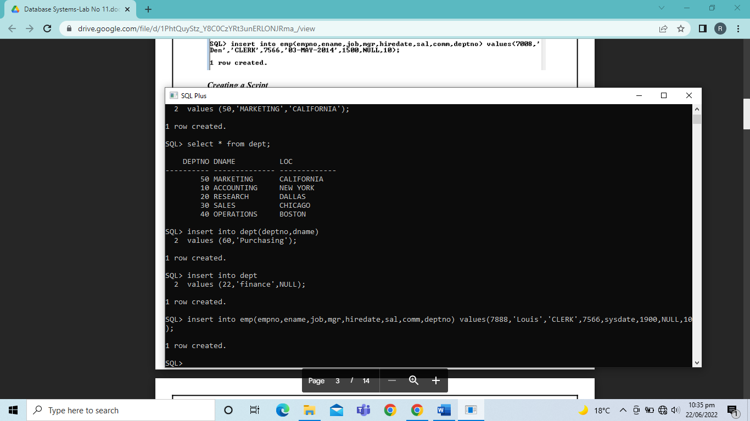

TASKS

1. Create the table MY_EMPLOYEE which has the following schema.

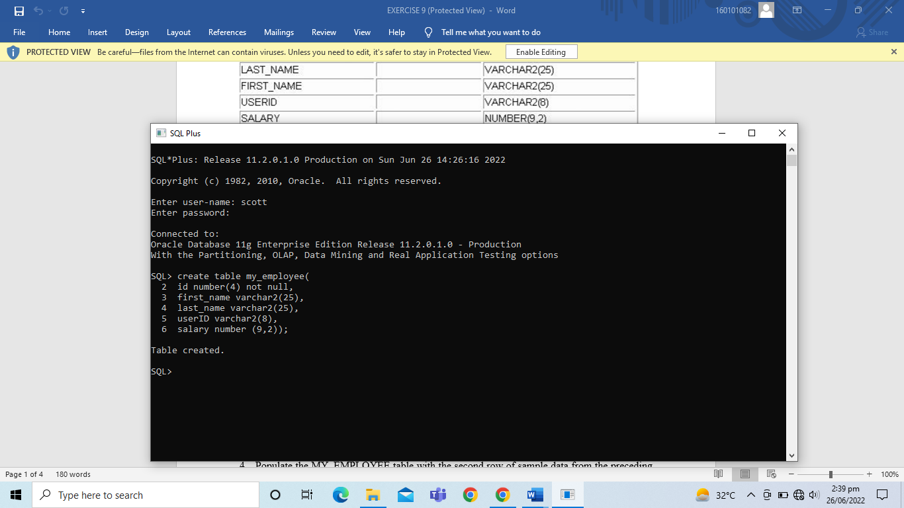

1. Describe the structure of MY_EMPLOYEE table.

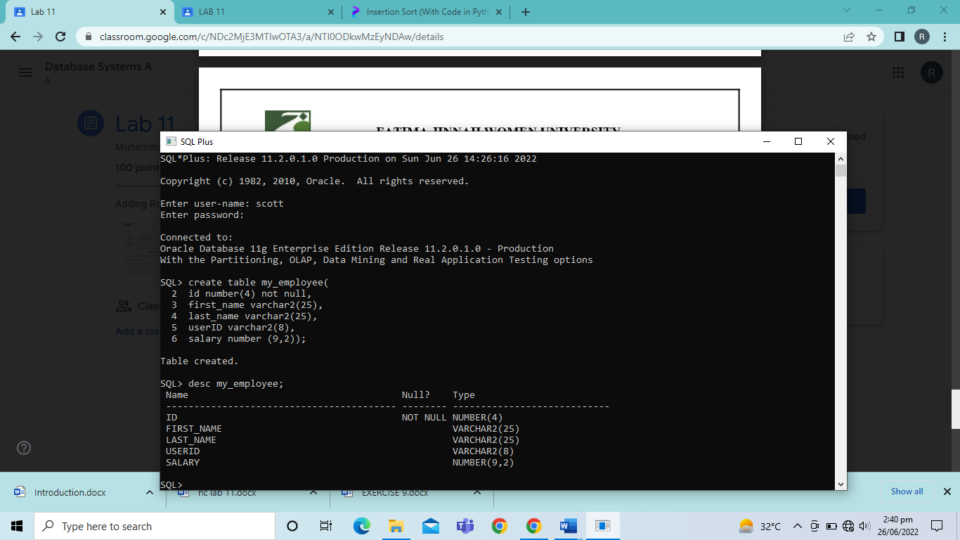

1. Add the first row of data to the MY_EMPLOYEE table from the following sample data. Do not list the columns in the INSERT clause.

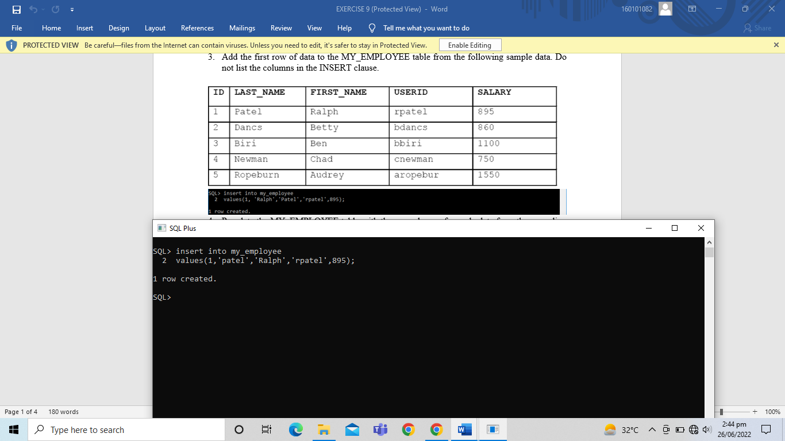

1. Populate the MY_EMPLOYEE table with the second row of sample data from the preceding list. This time, list the columns explicitly in the INSERT clause.

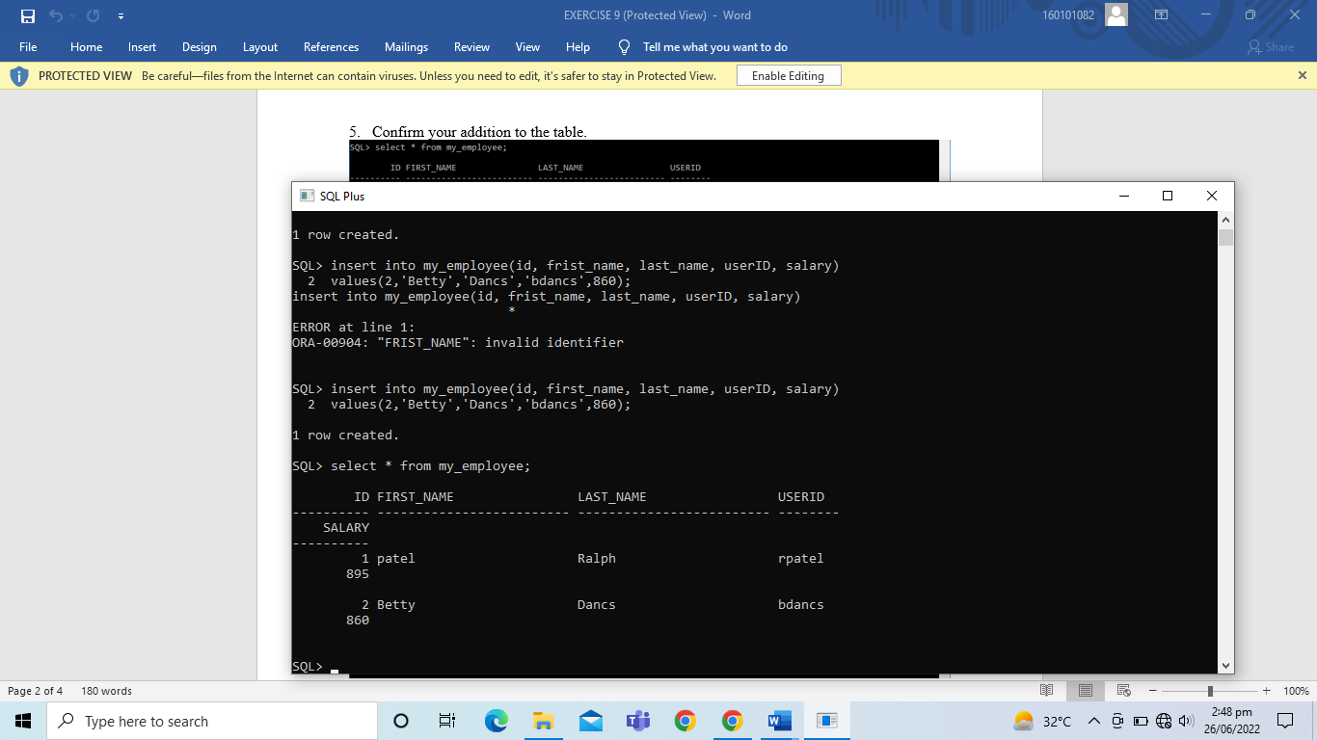

1. Confirm your addition to the table.



1. Populate the table with the next two rows of sample data by using the insert statement.

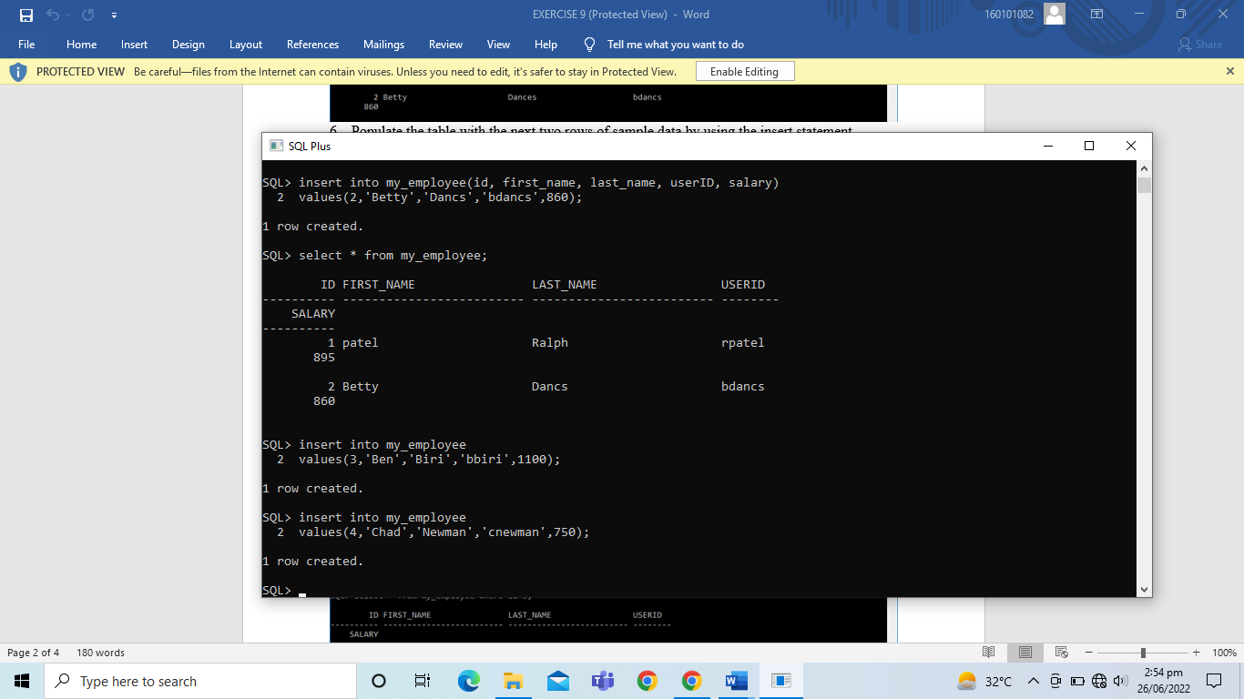

1. Make the data additions permanent.

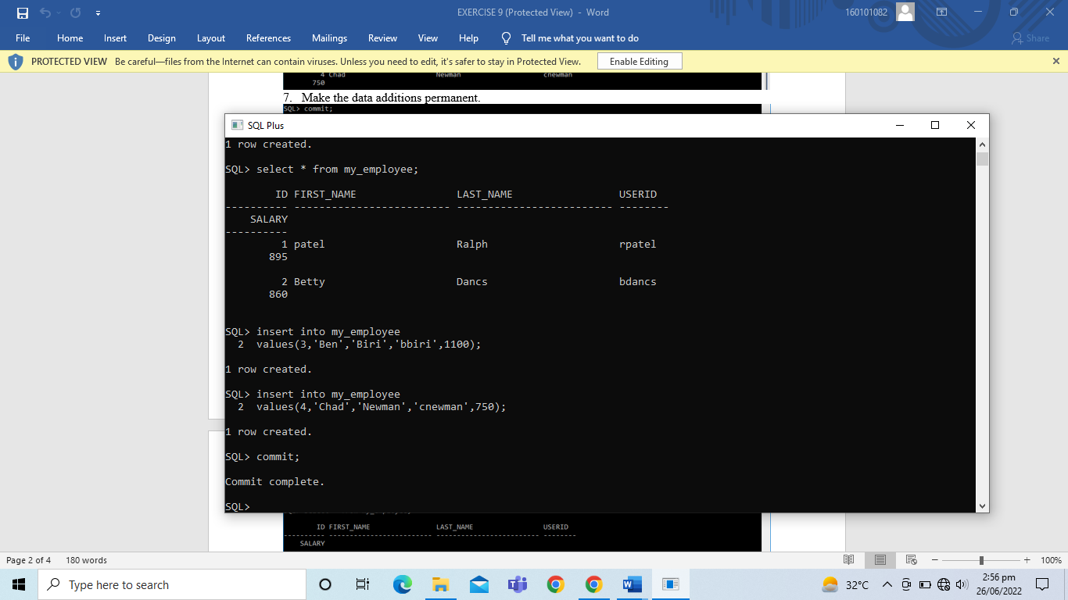

1. Change the last name of employee 3 to Drexler.

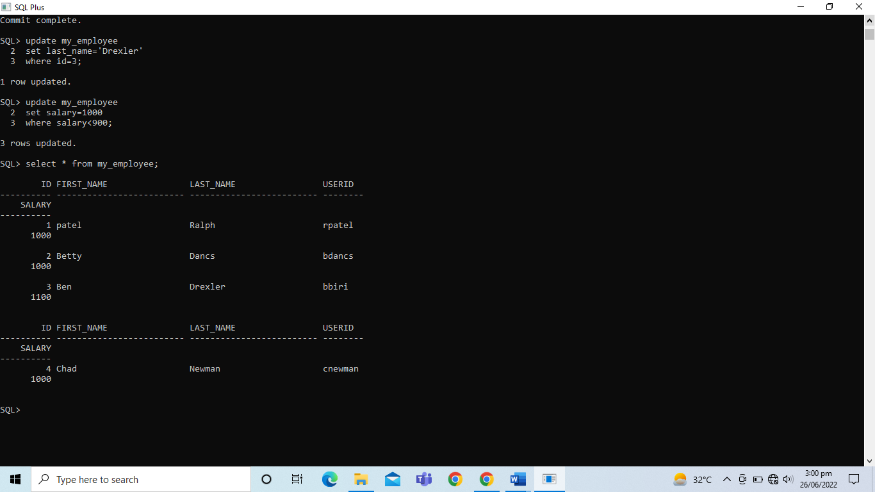

1. Change the salary to 1000 for all employees with a salary less than 900.



1. Verify your change to the table.



1. Delete Betty Dancs from the MY_EMPLOYEE table.

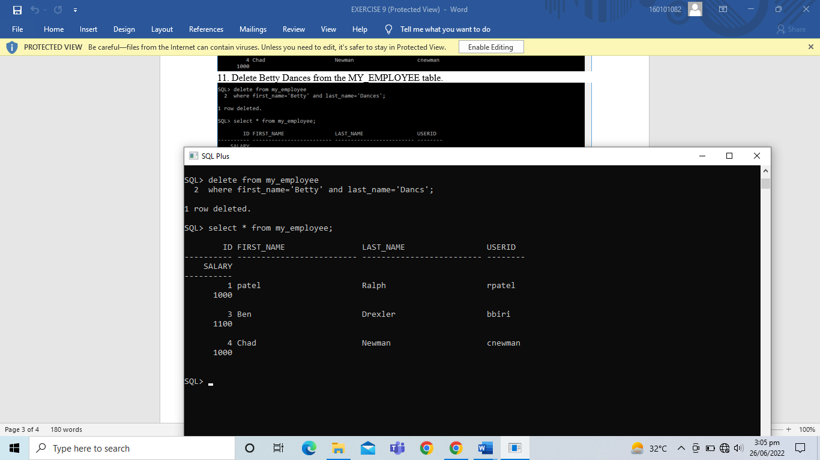

1. Empty the entire table.

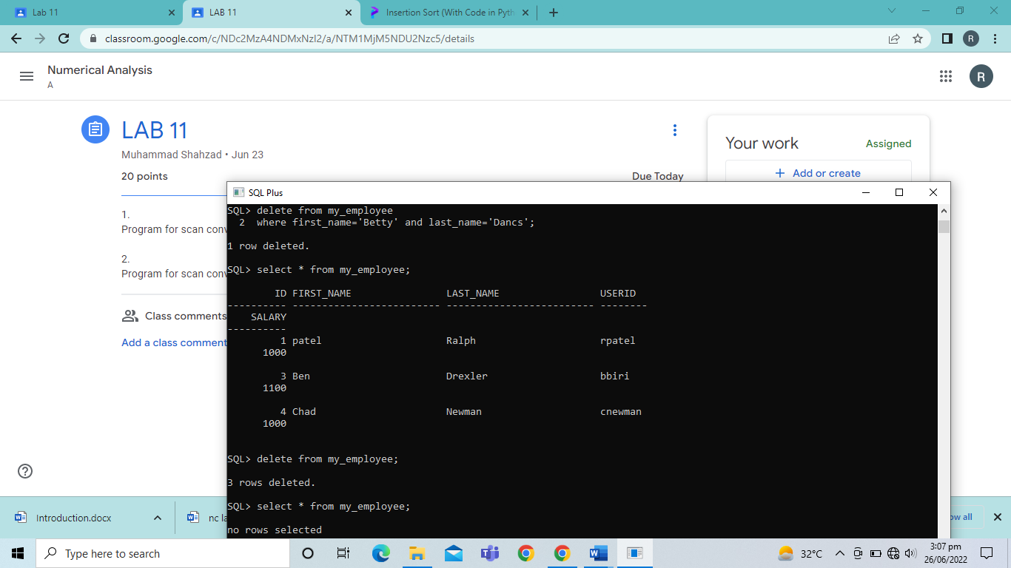

1. Confirm that the table is empty.



1. Discard the most recent DELETE operation without discarding the earlier INSERT statement.

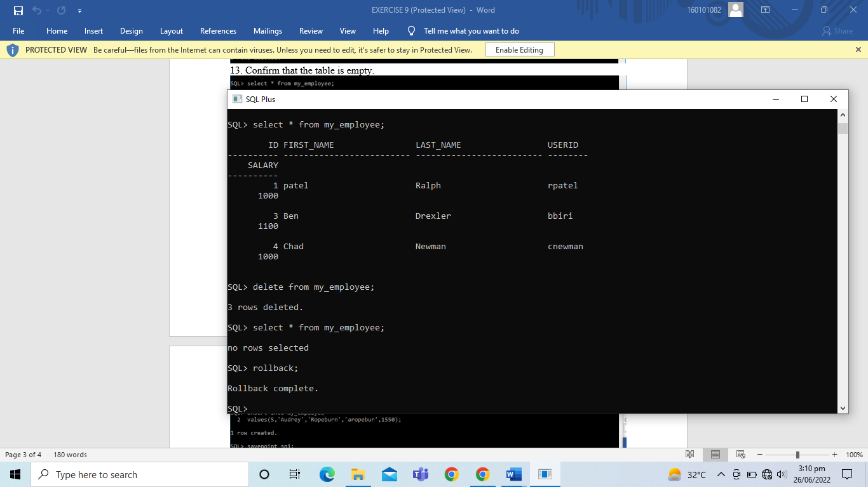

1. Confirm that the new row is still intact.

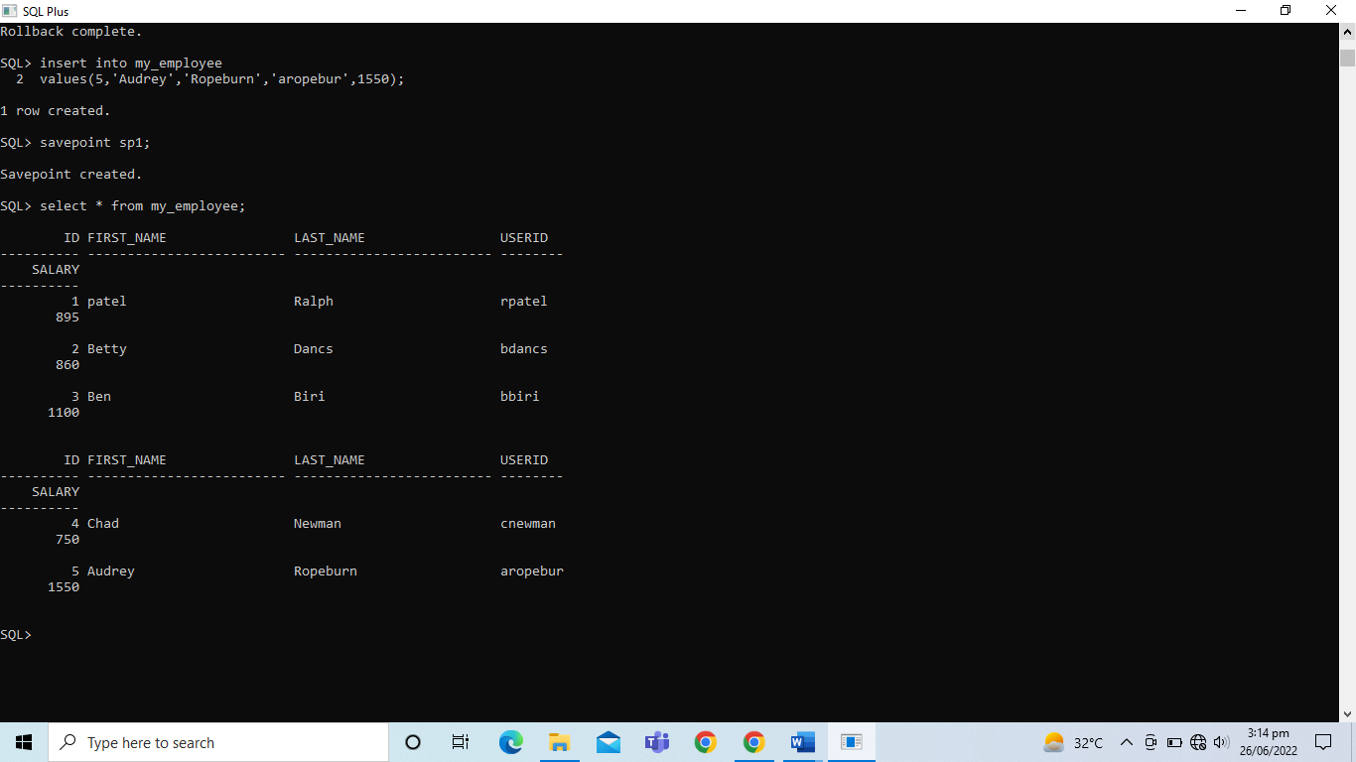

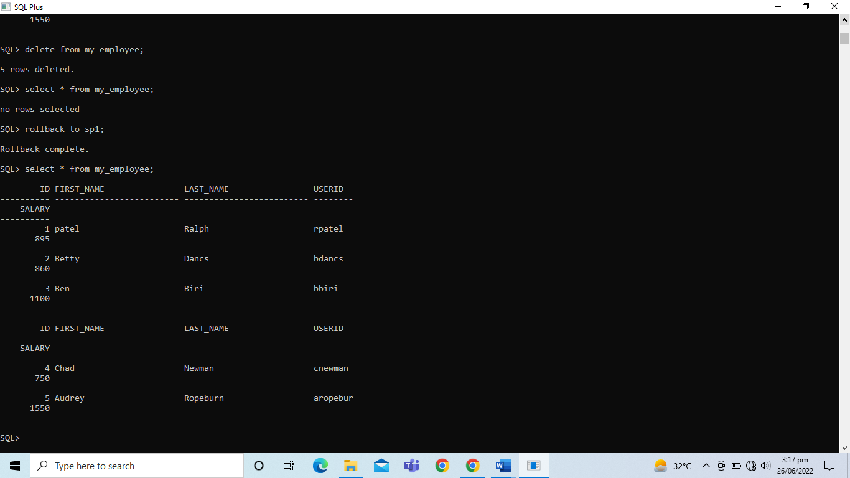

1. Make the data changes permanent.

